**🎨 HEURISTIC EVALUATION**

Heuristics evaluation is a method for identifying design problems in a UI.

Evaluators judge the design against a set of guidelines (called heuristics) that makes system easy to use.

**Nielsen’s 10 Usability Heuristics**

|  |  |  |
| --- | --- | --- |
| **Heuristic** | **Description** | **Example** |
| 1. Visibility of system status | Keep users informed of what’s going on. | A progress bar when uploading a file |
| 2. Match between system & real world | Use familiar language and concepts. | “Shopping cart” instead of “item repository” |
| 3. User control and freedom | Allow users to undo or redo actions. | “Undo” in Gmail after deleting an email |
| 4. Consistency and standards | Follow platform conventions. | Same layout for login screens across apps |
| 5. Error prevention | Design to prevent issues before they occur. | Preventing invalid date input in forms |
| 6. Recognition rather than recall | Minimize user memory load. | Auto-fill search history |
| 7. Flexibility and efficiency of use | Shortcuts and accelerators for power users. | Keyboard shortcuts like Ctrl+C |
| 8. Aesthetic and minimalist design | Avoid unnecessary elements. | Clean white space around content |
| 9. Help users recognize & recover from errors | Use plain-language error messages. | “Password too short—must be at least 8 characters.” |
| 10. Help and documentation | Provide assistance where needed. | Help centre, tooltips, walkthroughs |

**📝Case Study: Spotify Heuristic Evaluation**

Applying Jakob Nielsen’s 10 Heuristics to uncover UX & accessibility gaps and propose actionable fixes.

|  |  |  |  |  |
| --- | --- | --- | --- | --- |
| # | Heuristic | Observation | Issue | Suggestion |
| 1 | Visibility of System Status | Progress bar shows playback status. | No pause or rewind button on progress bar. | Add pause, play, rewind, forward buttons. |
| 2 | Match Between System & Real World | Uses music-related icons and terms. | Genre labels like “Lo-Fi” may confuse some. | Add tooltips or short descriptions. |
| 3 | User Control & Freedom | Users can skip or exit from the song. | No quick undo for "Remove from Playlist". | Add undo option for accidental removals. |
| 4 | Consistency & Standards | Uniform icon use (e.g., heart = like). | Shuffle and repeat icons are not clearly labelled. | Add brief text on long-press or hover. |
| 5 | Error Prevention | Warnings when deleting playlists. | No warning when removing songs from queue. | Add “Are you sure?” prompt. |
| 6 | Recognition over Recall | |  | | --- | | Recently played & suggestions shown. | | |  | | --- | | Some features are hidden in ‘more’ option like artist and album details, share. | | |  | | --- | |  |   Previous spotify had info floating at the top/bottom of song. |
| 7 | Flexibility & Efficiency of Use | Supports keyboard shortcuts (desktop). | No custom shortcuts or gestures on mobile. | Add swipe/gesture customization. |
| 8 | Aesthetic & Minimalist Design | Clean dark mode UI, with vibrant colors according to genre. | Ads break minimal flow on free version. | Offer cleaner ad integration. |
| 9 | Help Users Recover from Errors | Descriptive errors for login issues. | No clear fix when offline mode fails. | Add helpful “how to fix” messages. |
| 10 | Help & Documentation | Help Centre available via settings. | Hard to find during playback. | Add Help icon in Now Playing screen. |

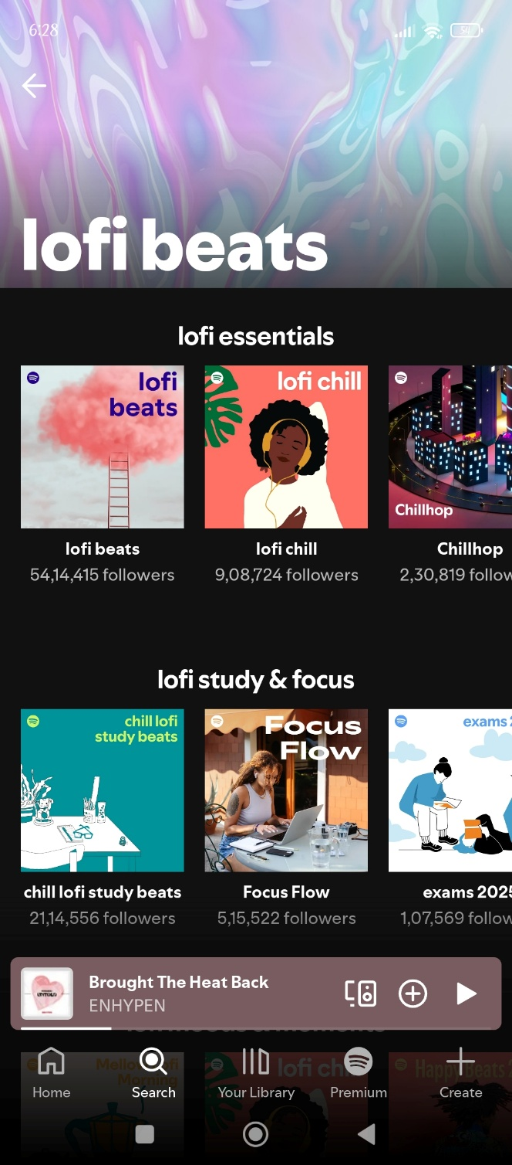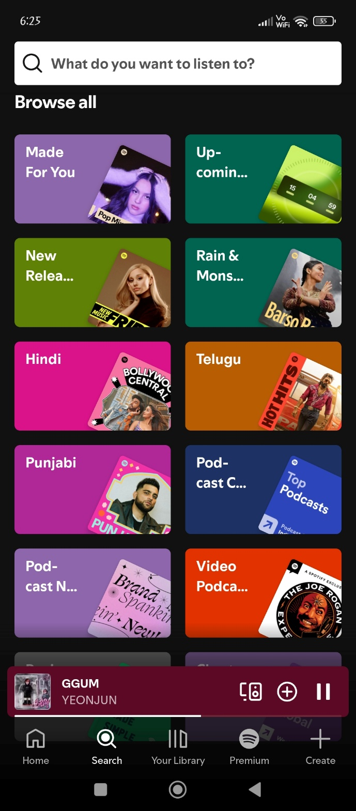

**2. Match Between System & Real World: Genre labels like “Lo-Fi” may confuse some.**

**1. *Visibility of System Status***: **No forward or rewind button on progress bar**

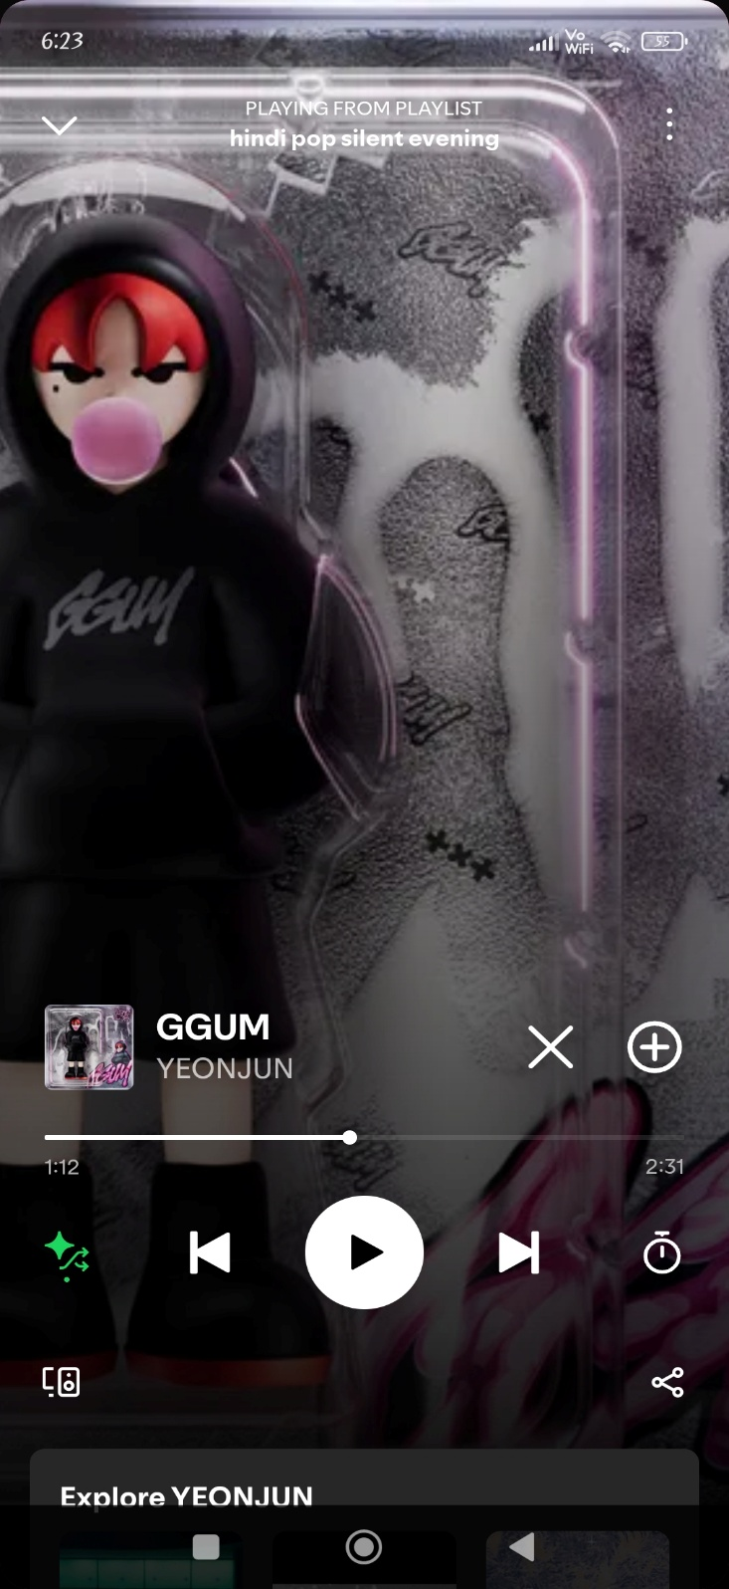

**4. Consistency & Standards: Shuffle and repeat icons are not clearly labelled.**

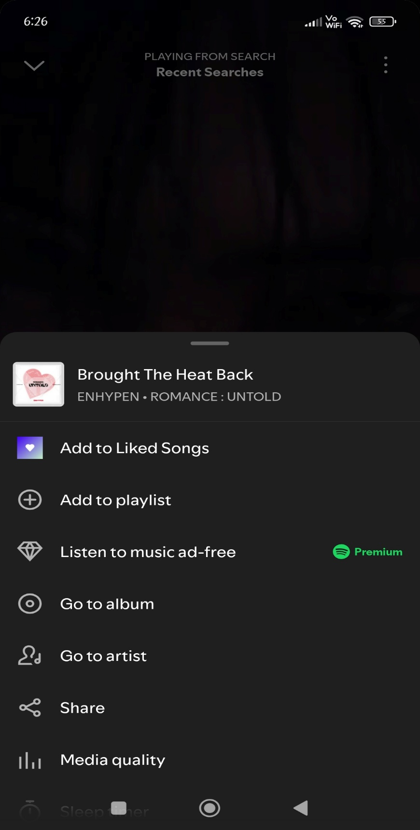

**6. Recognition over Recall: Some features are hidden in ‘more’ option like artist and album details, share**

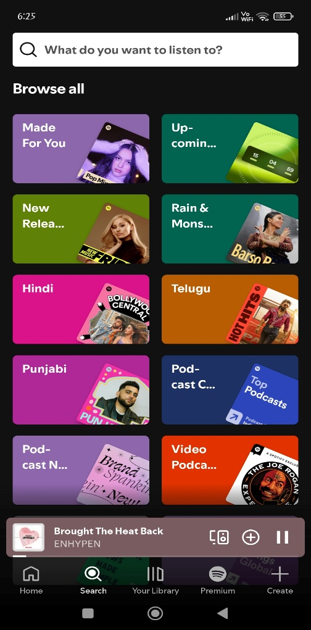

**UI: Neat organization - color scheme based on genre, making it easy to segregate and visually appealing.**

**🎨 ACCESSIBILITY IN UX DESIGN**

* Accessibility in UX refers to designing products that can be used by everyone, including individuals with disabilities (visual, auditory, motor, cognitive, or situational impairments).
* “Accessibility is not a feature; it’s a foundation.” – Salesforce UX
* Accessibility ensures that products are usable by people with a wide range of abilities and disabilities—including visual, auditory, cognitive, and motor impairments.

🖌️**Core Principles (POUR – WCAG Guidelines)**

|  |  |  |
| --- | --- | --- |
| Principle | Meaning | Example |
| Perceivable | Users must be able to perceive the information | Add alt text for images so screen readers can describe them. |
| Operable | Users must be able to navigate UI with various inputs | Make all features accessible via keyboard (not just mouse). |
| Understandable | UI must be easy to understand and use consistently | Use clear labels, avoid jargon, provide instructions. |
| Robust | Content should work with current and future technologies | Use semantic HTML and proper ARIA roles. |

🖌️**Key Accessibility Design Practices**

|  |  |
| --- | --- |
| Area | Key Action |
| Color & Contrast | Test contrast ratios; avoid relying solely on color |
| Text Alternatives | Add alt‑text, captions, transcripts |
| Keyboard Accessibility | Ensure logical tab order and visible focus |
| Forms | Use labels, placeholders, error messages |
| Markup & Roles | Use semantic HTML; apply ARIA where needed |
| Information Structure | Organize with headings and consistent layout |
| Empathy & Testing | Include users with disabilities in research and QA |

**📝Case Study: Instagram – Accessibility for Visual Content**

* The platform is highly visual, making it difficult for blind users to engage with posts.
* Stories and Reels had no alternative descriptions.
* Limited options for captioning videos, which affected users with hearing impairments.

**UX Accessibility Improvements**

|  |  |
| --- | --- |
| Issue | Solution |
| No image descriptions | Introduced automatic alt text using AI object recognition, and allowed manual alt text |
| Inaccessible buttons | Ensured all interactive elements had ARIA labels and clear icons |
| No captions in videos | Enabled closed captions for IGTV and Stories (manual and auto-generated) |
| Color contrast in Stories | Added tools for designers and creators to follow contrast guidelines (especially for text overlays) |

💡 **Outcome**

* Visually impaired users could now understand image content via screen readers.
* Instagram became more inclusive for deaf and hard-of-hearing users.
* Alt text also improved search and discovery algorithms.

Brief SUMMARY

|  |  |
| --- | --- |
| **Heuristic Design** | **Accessibility Design** |
| Expert-based review | User-centered review with diverse participants |
| Uses predefined rules (10 heuristics) | Uses standards (WCAG) and empathy |
| Focus on efficiency, learnability, clarity | Focus on inclusivity, equal access |
| Doesn’t guarantee accessibility compliance | Can overlap with usability if done with intent |

**🎨 COLOR THEORY**

|  |  |  |
| --- | --- | --- |
|  | **RYB Color Wheel** (Traditional) | **RGB Color Wheel** |
| **Primary Colors** | Red, Yellow, Blue | Red, Green, Blue |
| **Secondary** | Orange, Green, Violet | Cyan, Magenta, Yellow |
| **Based On** | Subtractive color mixing (pigments, paints) | Additive color mixing (light) |
| **Color Mixing** | Mixing pigments absorbs light (more = darker) | Mixing lights emits more light (more = lighter) |
| **Applications** | Art, traditional color theory | Digital graphics, UI/UX, photography |
| **Used In** | Painting, printing, art & design education | Digital screens, computers, TVs, cameras |

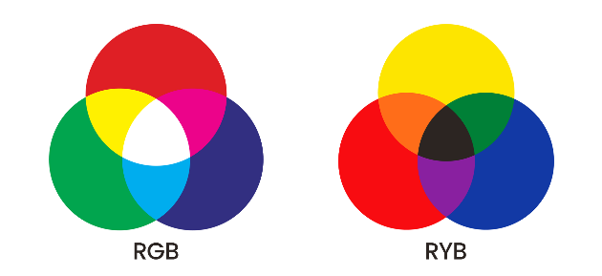 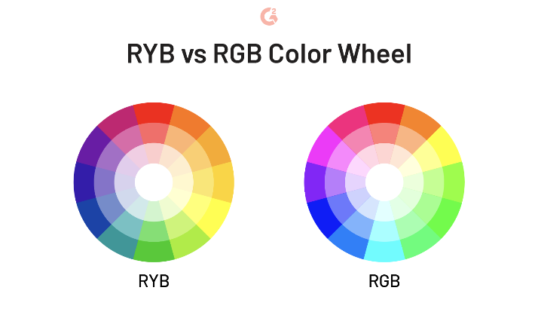

**Hex Codes (**#RRGGBB**):** Represents RGB values in hexadecimal:

* **HSL (Hue, Saturation, Lightness)**
* **HSV (Hue,Saturation,Values)**

**Hue** is measured in **degrees (0°–360°)** on a color wheel:

* 0° → Red
* 120° → Green
* 240° → Blue
* 60° → Yellow
* 180° → Cyan
* 300° → Magenta
* **Hue**: Basic Color (Angle on the color wheel)
* **Saturation**: 0% (Gray) - 100% (Full color)
* **Lightness**: 0% (Black) - 100% (White)
* **Value**: Brightness of the color (0–100%)

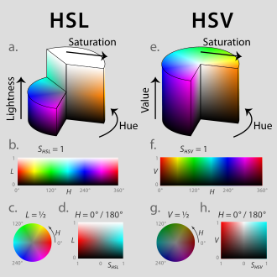

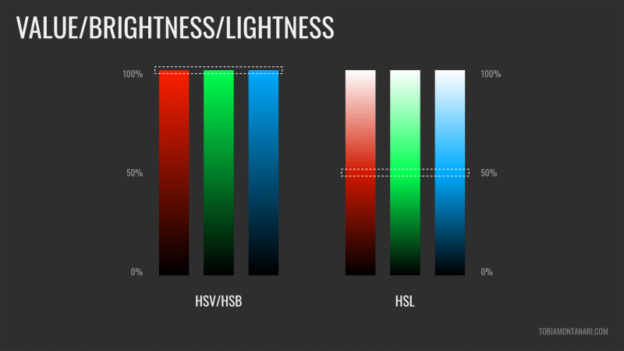

**1. Saturation:** The intensity or purity of a color.

* **High Saturation**: Pure, vivid color.
* **Low Saturation**: Washed out, grayish, or pastel-like.
* Example: Red at 100% saturation is bright red; at 0%, it becomes gray.



**2. Brightness :** How much light is emitted or reflected from a color.

* Also called **"Value"** in HSV (Hue, Saturation, Value).
* Affects whether a color is light or dark, without changing its hue.

**3. Contrast** : The difference in **lightness** or **color** between two elements.

* 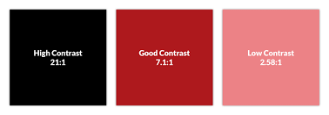**High contrast** = Easy to distinguish

(e.g., black text on white background).

* **Low contrast** = Hard to distinguish

(e.g., gray on white).

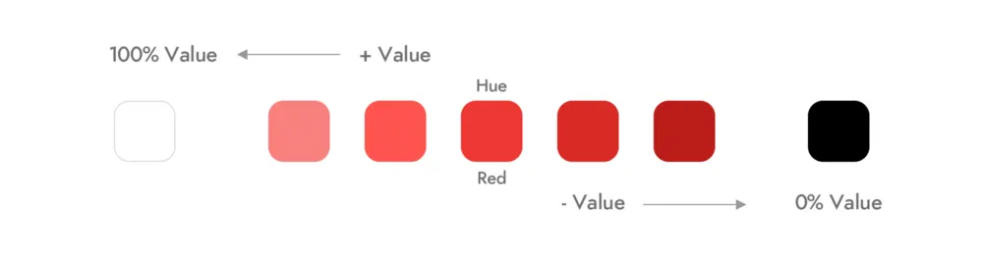

**4. Value** : The **lightness or darkness** of a color.

* Comes from the **HSV** model.
* High value = lighter colors, low value = darker colors.

**5. Lightness** : Similar to value, used in the **HSL** model.

* **0% lightness** = black, **100% lightness** = white.
* **50% lightness** = the pure color.

**📝Color Theory: Harry Potter Hogwarts Mystery**

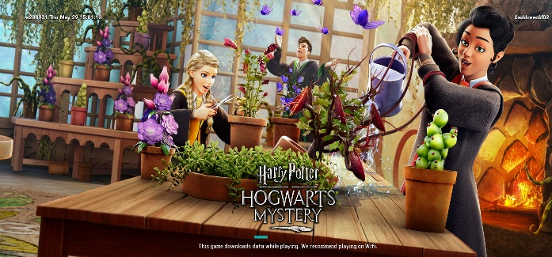

SSSC’25 with a wizarding world theme. What better way to explore Color Theory than through my favorite Harry Potter game — a beautifully designed experience full of magic, emotion, and atmosphere? Let’s analyzes how color palettes are used across key scenes.

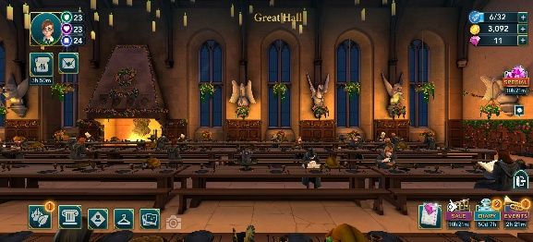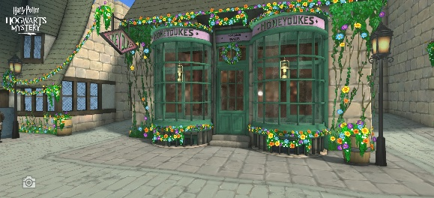**DIAGON ALLEY GREAT HALL**

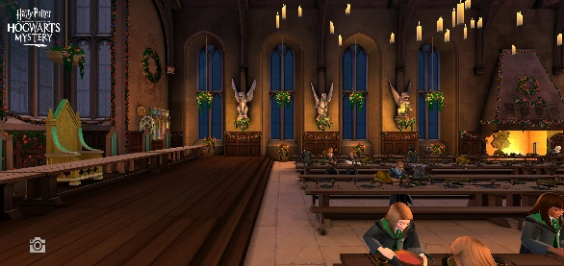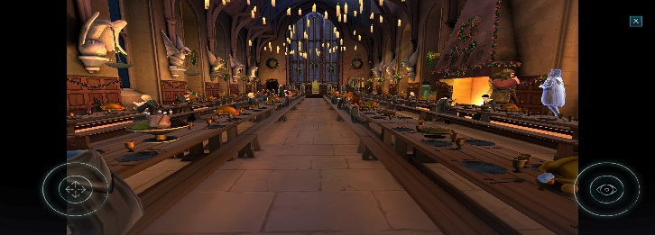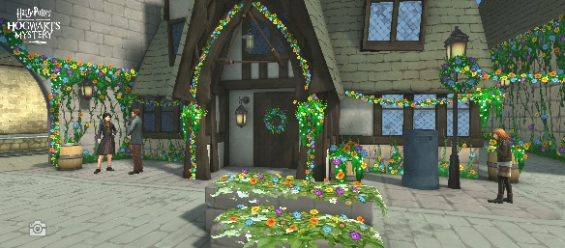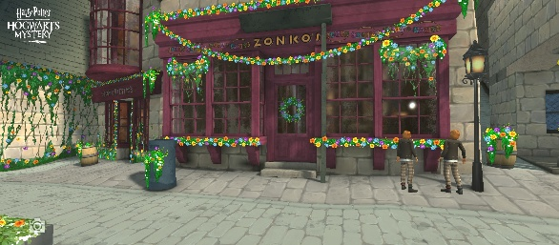

🎨 **ANALOGOUS** (Brown, Orange, Yellow)

🌡️: **Warm Palette** (Candlelight, brown tables, golden glow)

🧠 **Psychology**: Regal, communal, historic

🎨 **ANALOGOUS** (Beige, Yellow, Green)

🌡️: **Neutral Palette** (Stone walls, greys, burgundy stone fronts)

**🧠 Psychology** : Grounded and timeless, old wizarding architect

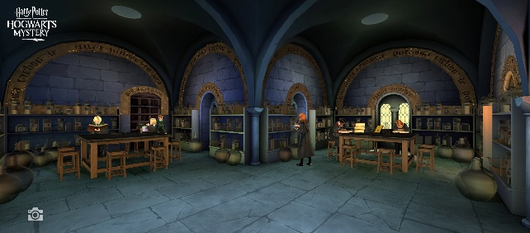**POTIONS CLASSROOM SLYTHERIN DORMITORY**

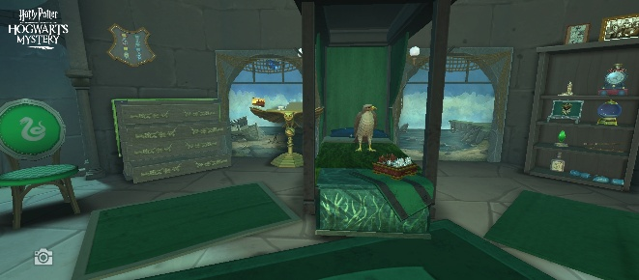

🎨 **MONOCHROMATIC** (Shades Of Green)

🌡️: **Cool Palettes** (Deep Greens, Grays, Teal )

🧠 **Psychology**: growth, ambition, cunning, secretive, elite

🎨 **COMPLEMENTARY** (Shades of Blue complements Yellow lights and Brown furniture)

🌡️: **Cold** (Blue-greys, stone walls, shadows, dim lighting)

🧠 **Psychology**: Mysterious, eerie, serious, chilly, intimidating

**QUIDITCH STADIUM**  **HAGRID’S HU**T

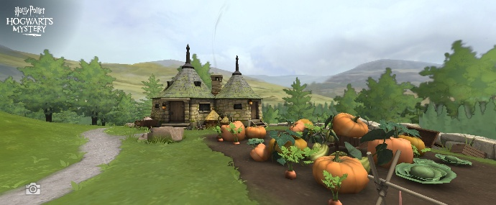

🎨 **COMPLEMENTARY** (Blue sky + Orange pumpkins + Green Ground and Greenish Brown Hut)

🌡️: **Warm Palette**: Cozy, rustic, inviting

🧠 **Psychology**:

* Green fields = Calm, nature
* Orange pumpkins = Warmth, comfort

🎨 **TETRADIC** (All house colors) + **COMPLEMENTARY** (Green ground & Blue skies)

🌡️: **Cool-Neutral Palette** (Vast green grass and blue sky)

🧠 **Psychology**: energetic, openness, colorful house stands spark excitement and identity, rivalry.